Project name: ANTI RAGGING PORTAL

Database Design Specification

DOCUMENT VERSION HISTORY

Document Version | Date Issued | Comments
1.0 | 22 - 10 -2019 | First version of the system

Table of Contents

Table of Contents 2
1 Introduction 3
2 Conventions followed 3
3 Entity Relationship Diagram 4-5
4 Tables 5-6

Introduction

The object/relationship pair is the cornerstone of the data model. These pairs can be represented graphically using the entity/relationship diagram. The ERD (Entity-Relationship Diagram) was originally proposed by Peter Chen. The primary purpose of the ERD is to represent entities (data objects) and their relationships with one another.
The ER Diagram of the assigned project ANTI RAGGING PORTAL has TWO major entities namely: Administrator, Student. These entities have their respective attributes enlisted with them. To make the working more clear few more entities have been added in this diagram namely, register, login, password.
This is the major reason as to why the colleges are choosing to take up anti ragging software in order to make the management of students life simpler and well-organized.

Conventions followed

HUNGARIAN CONVENTION

Entity Relationship Diagram

  - ADMIN

1.1ADMIN manages STUDENT.

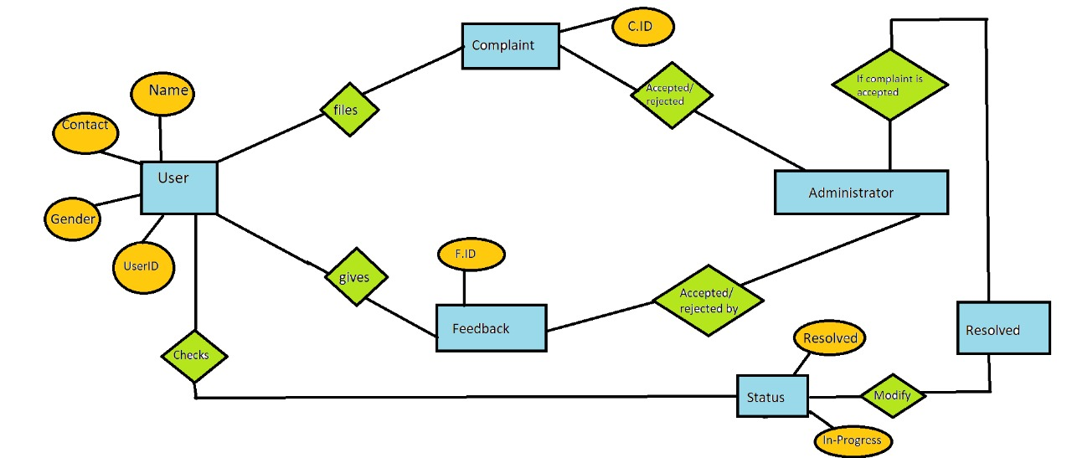

1.2 ADMIN accepts/rejects the complaint, feedback and can update the status of the complaint.

2.STUDENT

4 Tables

Database Tables are listed below –

4.1 User
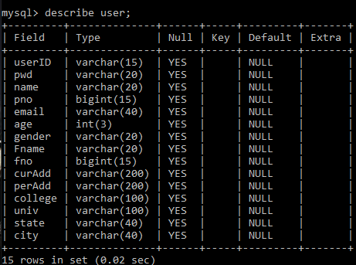

4.2 Complaint and Feedback

4.2.1 Complaint

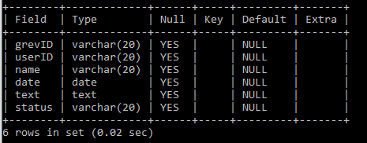

4.2.2 Feedback
